MicroLOAN SOUTH DAKOTA
Building South Dakota Communities

POLICIES AND PROCEDURES

MicroLOAN South Dakota
Policies and Procedures

INTRODUCTION

The policies and procedures outlined in this document provide a framework within which MicroLOAN South Dakota will operate. The policies herein have been set by a Loan Committee consisting of seasoned bankers and business people with a goal of furthering economic development for the State of South Dakota. The parameters of the program should be adhered to and changes in the policies and procedures can only be made by the Loan Committee or the Lender of such loan funds.

Periodic reviews of the program will be conducted by the Governor’s Office of Economic Development (GOED). The policies should remain flexible enough to enable the program to be able to meet the needs of the industries in our state.

The intent of the program is to provide low interest, gap financing for small businesses for which other types of financing might not be available. The primary bank or credit union should assist applicant in preparing the application for filing with the Governor’s Office of Economic Development. Once the Loan Committee approves an application, the primary bank or credit union will be responsible for closing both loans. GOED will then purchase the loan which conforms to the MicroLOAN criteria. The primary bank or credit union will establish an automatic withdrawal plan for borrower's monthly payments to the servicing entity.

The borrower should be made aware that any prepayment of principal of the bank’s or credit union’s loan will cause a corresponding pro-rata principal reduction of the MicroLOAN.

CREDIT CRITERIA

MicroLOAN South Dakota will base its credit decisions on the following criteria:

1. The small business must meet the eligibility requirements of the program.

2. The small business must show the ability to service the debt.

3. The management of the small business must have the ability to conduct the business and show commitment to the project.

4. The payment history of the small business with other lenders and creditors must be satisfactory.

5. The review of proposed collateral must be satisfactory.

6. The credit history of borrowers and guarantors of the loan must be satisfactory.

A loan payment will be considered late when the scheduled loan payment has not been made on or prior to its scheduled date and late payments will incur the appropriate fees. The borrower’s primary bank or credit union will determine the actions to be taken for delinquent loan payments.

Eligibility Requirements

• Loans can be made available to small businesses within the borders of South Dakota and South Dakota residents, including main street and retail operations for working capital, equipment, real estate or other fixed asset project costs.

• Businesses involved in any type of legal gaming operations or gambling may not derive more than 30% of their annual gross revenue from such activities. However, if the purpose of the business is gambling such as pari-mutual betting, racetrack or a gambling casino, it is not eligible, regardless of the percentage of gross income derived from gambling. Businesses involved in pornography, illicit activities or any affiliated activity are also prohibited from applying for MicroLOAN South Dakota
funds. Any business which has received MicroLOAN South Dakota funds and subsequently derives any portion of their revenue from the previously mentioned activities prior to repaying all principal and interest on their MicroLOAN South Dakota loan, shall be deemed to be in default of their MicroLOAN agreement. Non-profit businesses and agricultural
production are not eligible to apply for MicroLOAN funds. MicroLOAN
funds may not be used for refinancing purposes.

• Applicants must have a primary bank or credit union in place, that agrees with the Loan Purchase Agreement, prior to applying to the South Dakota MicroLOAN Fund.

Application Process

• The MicroLOAN application must be completed and submitted to the Governor’s Office of Economic Development with a cover letter from the primary bank or credit union. The primary bank or credit union must agree to the Loan Purchase Agreement. The application must include the primary bank’s or credit union’s credit analysis, including personal financial statements for applicant(s) and any guarantors, and the terms of the bank's or credit union’s participation. Please see attached application for the MicroLOAN Fund.

• The Governor’s Office of Economic Development will take applications to the next scheduled loan committee meeting usually within 30 days of receiving a complete application package for the MicroLOAN program.

Loan Criteria/Structure of Loans

• The maximum loan amount will be $100,000.00 and the minimum loan amount will be $1,000.00. The MicroLOAN program can participate up to
50% of the total financing necessary and the primary bank or credit union may not fund less than 50% of the total financing necessary. Total project costs may not exceed $750,000.

• Total MicroLOAN proceeds outstanding at any one time, to a single borrower, may not exceed $100,000. MicroLOAN funds may not be used for refinancing purposes.

• The equity injection requirement may be determined by primary bank or credit union. The Loan Committee may require an equity injection when the MicroLOAN portion of a project exceeds $20,000.

• The interest rate for new applicants is 3%. The Loan Committee may adjust the rate on a quarterly basis, for new loans. The term of the loan will not exceed five years except in certain situations where the amortization period may be up to 10 years. The period will be over the useful life of the asset being financed. Depending on the available cash flow of the
company the Loan Committee can determine an earlier balloon payment shall be made.

• The loan will be secured by a subordinated position on the business assets or a subordinated real estate mortgage. Additional collateral may be required. The subordination will be to the primary bank or credit union

involved in the project only. The collateral must be identical to that securing the primary bank’s or credit union’s companion loan. However, in certain situations the Loan Committee may ask for additional collateral.

• An administrative fee will be assessed in the amount of $50.00 or one and one half percent of the loan amount, whichever is greater. This fee will be paid by the applicant. The applicant will also pay for any filing fees for security instruments, title insurance, appraisals, and surveys required. The applicant will also pay any other costs associated with closing of the loan. The Loan Committee will review the administrative fees periodically.

Administrative Functions of Program

• GOVERNOR’S OFFICE OF ECONOMIC DEVELOPMENT will
- Process the application as provided by the applicant.
- Take the application before the Loan Committee.
- Has enacted a Servicing Agreement with BankWest, Inc. to monitor payments and accept disbursements from GOED.
- BankWest will review the loan closing information prior to disbursing funds to make sure security instruments are in place.
- Make recommendations to the Loan Committee.

• LOAN COMMITTEE will
- Review applications as brought before them and will render an approval or not approve the loan as requested.
- Review any additional requests as submitted by primary lender.
- Review the administrative loan fee periodically to determine adequacy.

• PRIMARY BANK OR CREDIT UNION will
- Provide a credit analysis to the GOED for review, and agree to the Loan
Purchase Agreement.
- Provide a plan for liquidation or an extension of the loan if a loan is 60 days past due.
- Be responsible for the closing of both loans, providing the necessary loan documentation to the GOED, and setting up a monthly automatic payment plan for the borrower, prior to receiving funds.

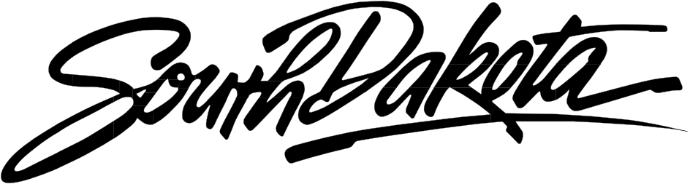

Governor’s Office of Economic
Development

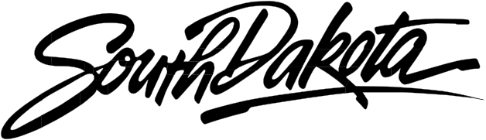MicroLOAN

Building South Dakota Communities

Governor’s Office of Economic Development
711 E. Wells Avenue
Pierre, South Dakota 57501-3369

Phone: 605-773-4633
Fax: 605-773-3256
Internet: http://www.sdreadytowork.com

MicroLOAN South Dakota Loan Program
Borrower Application

Date of Application
Individual completing this form
Individual’s telephone number
Company Affiliation
Primary Lender--Include cover letter

Section 1. Applicant Information

Name of Applicant Business
Name (address) of parent company
Name (address) of affiliates
Name (title) of contact person
Business Address
City, State, Zip code
Business Telephone number
Fax number
E-mail address
Business or federal tax ID Number
SD sales tax number
SD unemployment insurance number
Primary business activity
NAICS code
Date business established
Date business established in SD
Business type
Fiscal year end

Management Information:
List all the officers, directors, or general partners. Attach resumes.
Name & Title | Address & Phone  Number | Compensation | Social Security  Number

Major Stockholders, Partners or Proprietors:
(Totaling 100% ownership. Attach Personal financial statement and resumes.)

Name & Title | Address & Phone  Number | Compensation | Social Security  Number

Banks or credit unions where business and principal personal accounts are maintained:
Name | City/State | Phone # | Type of  Account | Account #

Present business trade creditors or trade references:

Name | Address | Phone # | Type of  Account | Balance | Date

Section 2. Purpose of the Loan

Description of the Project:

Date project will begin
Estimated completion date
Is loan applicant planned occupant?
Legal owner of the site

Project Costs

 | Uses ($$) | Sources ($$)
Land
Building
Site Improvements
Equipment
Equipment Installation
Costs
Inventory
Receivables
Other Costs
Financing Fees
Total
(Attach information on specific data of the items above including description of
equipment, inventory, land and building to be acquired, site improvements to be made, etc.)

Sources of Long Term Financing (Include MicroLOAN Funds, Primary
Lender and any other sources):

Name of Lenders | Purpose | Amount | Terms | Collateral
*Positions may be negotiated among the parties involved.

Source of Interim Financing: Source of Equity Contribution:

Section 3. Marketing Plan

Please attach Marketing Plan or Business Plan.

Section 4. Financial Information
Please attach last three years historical financial statements and/or tax returns to include a balance sheet and income statement and three years of proformas including a balance sheet and income statement. Please attach personal financial statements for applicant(s) and guarantors and current credit reports for each. Please attach a cover letter from your bank or credit union including the terms of their portion of the loan.

Section 5. Employment Information

Please summarize current and the next three year projected job creation regarding this project.
 | Current  20___ | Year 1 | Year 2 | Year 3 | Year 4 | Year 5 | Total
Managers & Administrators
Professional & Technical
Sales
Clerical
Service
Production/Maintenance
Total Employees

Please summarize wage and benefits paid to employees:

Certification
Governor’s Office of Economic Development is an equal opportunity lender.
Under the Equal Credit Opportunity Act, it is illegal to discriminate in any credit transaction on the basis of race, color, national origin, religion, sex, marital status or age.

The applicant realizes that the Governor’s Office of Economic Development and any of its boards or committees may not process any application that is not complete. Incomplete applications will be returned to the applicant for completion.

The applicant further understands that there is no right to financing under the MicroLOAN Program. Approval of the application by the Loan Committee does not constitute a guarantee that the project will receive financing under the Program. Financing is contingent on the availability of MicroLOAN Program funds, compliance will all Program requirements, execution of all Agreements and the closing of the project loans by the Originating Bank or Credit Union.

“I declare and affirm under the penalties of perjury that the claim (petition, application, information) has been examined by me, and to the best of my knowledge and belief, is in all things true and correct.” There is no intent to deceive or defraud the Governor’s Office of Economic Development or any potential participant in any loans to finance this project.

APPLICANT BUSINESS: OFFICER’S SIGNATURE: OFFICER’S NAME/TITLE: TELEPHONE NUMBER: Revised 7/19

DATE:

